VILLA I & II ACTIVITY CALENDAR JULY 2025
Sunday | Monday | Tuesday | Wednesday | Thursday | Friday | Saturday
Happy Birthday!!  Janice H. 7th  Marion K. 13th  Nancy N. 14th  Robert B. 26th | Brewers  Home games:  7-9th  11-13th  25-27th  28-30th  Away games:  1st-3rd  4-6th  18-20th  21-23rd | 1  - Stretches w/ LE  - Circle of Friends  Game of the week:  International Joke Day!    This Photo by Unknown Author is licensed under CC BY-NC-ND | 2  Catholic Communion Visits/ Services:  9a- V1, 10:15a- V2  - Hymn Sing along  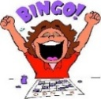  BINGO! With Hershey kisses | 3  - Coffee & Conversation  10a: All Faiths Service w/ Pastor Steve in chapel & channel 955  Creativity Corner:  Patriotic Popcorn | 4  Happy 4th of July   | 5  Residents Choice w/ PCA’s  5p: Lawrence Welk Show Channel 8
6  10a: Worship Service with Pastor Steve  Channel 955 Chapel  11a: Polka, Polka, Polka  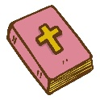  Channel CW14 | 7  Rosary & Prayers w/ Bob:   8:45a-V2, 9:30a- V1  Bible study w/ Pastor Steve:  9:15a- V1, 9:30a-V2  World Chocolate Day | 8  - Stretches w/ LE  - Circle of Friends  Patriotic Watercolor | 9  Catholic Communion Visits/ Services:  9a- V1, 10:15a- V2  - Hymn Sing along  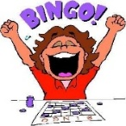  BINGO! | 10  - Coffee & Conversation  10a: All Faiths Service w/ Pastor Steve in chapel & channel 955  Creativity Corner:  Cross Craft | 11  - Social Hour  - Manicures  10:15a-12p: Trishaw Rides  Patriotic Trivia | 12  Residents Choice w/ PCA’s  5p: Lawrence Welk Show Channel 8
13  10a: Worship Service with Pastor Steve  Channel 955 Chapel  11a: Polka, Polka, Polka  Channel CW14 | 14  Rosary & Prayers w/ Bob:  8:45a-V2,  9:30a- V1  Bible study w/ Pastor Steve:  9:15a- V1  9:30a-V2  Left, Right, Center dice game | 15  - Stretches w/ LE  - Circle of Friends  Game of the week:  Tic, tac, toe bag toss | 16  Catholic Communion Visits/ Services:  9a- V1, 10:15a- V2  - Hymn Sing along  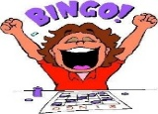  BINGO! | 17  - Coffee & Conversation  10a: All Faiths Service w/ Pastor Steve in chapel & channel 955  Creativity Corner:  Potpourri bags  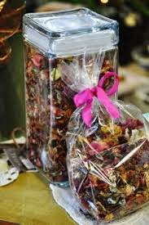 | 18  - Social Hour  - Manicures  10:15a-12p: Trishaw Rides  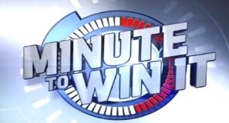  This Photo by Unknown Author is licensed under CC BY | 19  Residents Choice w/ PCA’s  5p: Lawrence Welk Show Channel 8
Sunday | Monday | Tuesday | Wednesday | Thursday | Friday | Saturday
20  10a: Worship Service with Pastor Steve  Channel 955 Chapel  11a: Polka, Polka, Polka  Channel CW14 | 21  Rosary & Prayers w/ Bob:  8:45a-V2,  9:30a- V1  Bible study w/ Pastor Steve:  9:15a- V1  9:30a-V2  Dirt Pudding cups | 22  - Stretches w/ LE  - Circle of Friends  Game of the week:  Bunco! | 23  Catholic Communion Visits/ Services:  9a- V1, 10:15a- V2  - Hymn Sing along  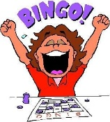  BINGO! | 24  - Coffee & Conversation  10a: All Faiths Service w/ Pastor Steve in chapel & channel 955  White Elephant game | 25  - Manicures  - Social Hour  10:15a-12p: Trishaw Rides  Table Tennis | 26  Residents Choice w/ PCA’s  5p: Lawrence Welk Show Channel 8
27  10a: Worship Service with Pastor Steve  Channel 955 Chapel  11a: Polka, Polka, Polka  Channel CW14 | 28  Rosary & Prayers w/ Bob:  8:45a-V2,  9:30a- V1  Bible study w/ Pastor Steve:  9:15a- V1  9:30a-V2  Dance party & sing along | 29  - Stretches w/ LE  - Circle of Friends  Game of the week:  Memory Game | 30  Catholic Communion Visits/ Services:  9a- V1, 10:15a- V2  - Hymn Sing along  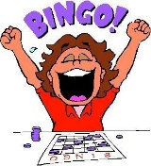  BINGO! | 31  - Coffee & Conversation  10a: All Faiths Service w/ Pastor Steve in chapel & channel 955  Nertz | Why We Celebrate  The Fourth of July!!  The Fourth of July, also known as Independence Day, is celebrated in the United States to commemorate the adoption of the Declaration of Independence on July 4, 1776. This declaration officially declared the thirteen American colonies’ separation from Great Britain. It’s a day for celebrating American freedom and nationhood.

