VILLA ACTIVITY CALENDAR MAY 2026
Sunday | Monday | Tuesday | Wednesday | Thursday | Friday | Saturday
 | V1- 8:30-11:30a V2- 12:30p-3:30p | V2- 8:30-11:30a V1- 12:30p-3:30p | V1- 8:30-11:30a V2- 12:30p-3:30p | V2- 8:30-11:30a V1- 12:30p-3:30p | V1- 8:30-11:30a V2- 12:30p-3:30p | 2  Residents Choice w/ PCA’s  11:30-4pm: Kentucky Derby  Channel: NBC & Peacock
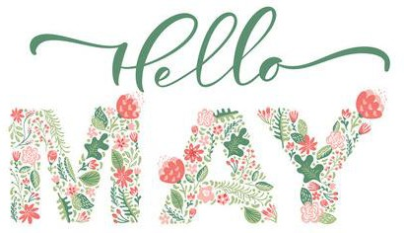 |  |  |  |  | 1  - Chair Yoga- LE  - Pet Visit  - Social Hour     Fit Minds: Kentucky Derby Roll & Race
 |  |  |  |  |  | 
 |  |  | No Villa Birthdays |  |  | 2p: Touch towns: Music Channel: 955
 |  |  |  |  |  | 5p: Resident choice
 |  |  |  |  |  | 
3  10a: Worship Service with Pastor Steve Channel: 955 Chapel  11a: Polka, Polka, Polka  Channel  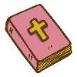 | 4  Rosary & Prayers w/ Bob: 8:45a- V2, 9:30a-V1  Bible study w/ Pastor Steve: 9:15a- V1, 9:30a- V2  Sensory Hour: Tea Party Social  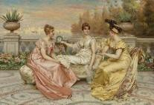 | 5  - Drums- LE  - Book on Tape  Game of the Week:  Hot Pepper Panic  with Margaritis  Cinco de Mayo | 6  - Catholic Communion-Visits/ Services  - Hymn Sing along  - BINGO!!!  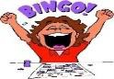 | 7  - Friendship Circle  - Manicures  10a: All Faiths Service w/ Pastor Steve in Chapel or channel 955  Creativity Corner:  Paper Flower Project   | 8  - Chair Yoga- LE  - Pet Visit  - Social Hour  Fit Minds: Mother’s Day Memories &  Traditions  Mother’s Day Flower Delivery | 9  Residents Choice w/ PCA’s  2p: Touch towns: Music Channel: 955  5p: Resident choice
10  10a: Worship Service with Pastor Steve  Channel: 955 Chapel | 11  Rosary & Prayers w/ Bob: 8:45a- V2, 9:30a-V1  Bible study w/ Pastor Steve: 9:15a- V1, 9:30a- V2  Sensory Hour: 3D Flower Painting  Wear Purple / Blue | 12  - Drums- LE  - Book on Tape  Game of the Week:  Flower Symmetry & Matching  2p-3p: Chapel  Wine Pairing Experience  Wear Yellow / Sunflowers | 13  - Catholic Communion-Visits/ Services  - Hymn Sing along  - Floral BINGO!!!  Wear Floral Prints | 14  - Friendship Circle  - Manicures  10a: All Faiths Service w/ Pastor Steve in Chapel or channel 955  1-3p: Chapel Spring Fling  60s Flower Power w/ Let’s Be Frank    Dress 60s- Flower Power | 15  - Chair Yoga- LE  - Garden Club (seed prep)  - Social Hour      Fit Minds:  Memories in Bloom  (Share a photo & Story)  Wear Red/ Roses | 16  Residents Choice w/ PCA’s  2p: Touch towns: Music Channel: 955        5p: Resident choice
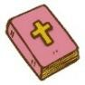
11a: Polka, Polka, Polka
Channel
HAPPY MOTHER’S
DAY! ● • •
*Start of Woodside
Week!!

Sunday | Monday | Tuesday | Wednesday | Thursday | Friday | Saturday
17  10a: Worship Service with Pastor Steve Channel: 955 Chapel  11a: Polka, Polka, Polka  Channel | V1- 8:30-11:30a V2- 12:30p-3:30p | V2- 8:30-11:30a V1- 12:30p-3:30p | V1- 8:30-11:30a V2- 12:30p-3:30p | V2- 8:30-11:30a V1- 12:30p-3:30p | V1- 8:30-11:30a V2- 12:30p-3:30p | 23  Residents Choice w/ PCA’s  2p: Touch towns: Music Channel: 955  5p: Resident choice  
 | 18  Rosary & Prayers w/ Bob: 8:45a- V2, 9:30a-V1  Bible study w/ Pastor Steve: 9:15a- V1, 9:30a- V2  Sensory Hour:  Ice Cream Making | 19  - Drums- LE  - Book on Tape  Starbucks Social  Game of the Week:  Penny Drop | 20  - Catholic Communion-Visits/ Services  - Hymn Sing along  - BINGO!!! | 21  - Friendship Circle  - Manicures  10a: All Faiths Service w/ Pastor Steve in Chapel or channel 955  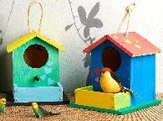  Creativity Corner: Building a Bird House | 22  - Chair Yoga- LE  - Pet Visit  - Social Hour    Fit Minds:  Turtle Trivia  (live Tortoise visit)
24  10a: Worship Service with Pastor Steve Channel: 955 Chapel  11a: Polka, Polka, Polka  Channel | 25  Memorial Day   | 26  - Drums- LE  - Book on Tape  Game of the Week:  UNO  2p-3p: M3  Fernando    *Celebrate April & May Birthdays* | 27  - Catholic Communion-Visits/ Services  - Hymn Sing along  - Grape Popsicle Day!  - BINGO!!! | 28  - Friendship Circle  - Manicures  10a: All Faiths Service w/ Pastor Steve in Chapel or channel 955  Creativity Corner:  Hummingbird watercolor painting | 29  - Chair Yoga- LE  - Pet Visit  - Social Hour    Fit Minds: Number Search | 30  Residents Choice w/ PCA’s  2p: Touch towns: Music Channel: 955  5p: Resident choice
31  10a: Worship Service with Pastor Steve Channel: 955 Chapel  11a: Polka, Polka, Polka  Channel | Female Ruby-throated Hummingbird  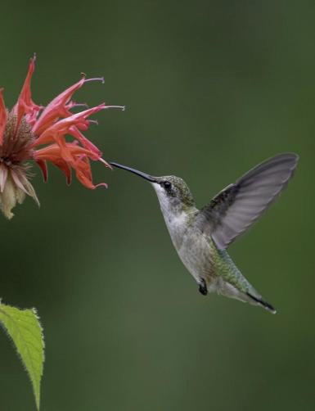 | Bird of the Month: Hummingbird  - Hummingbirds represent love, peace, hope and the ability to find joy in everyday life.  - Hummingbirds are the only birds capable of flying in a figure-eight pattern, including backward and vertically.  - Hummingbirds can beat their wings 53 times a second.  - The Ruby-throated Hummingbird is the only common breeding hummingbird in Wisconsin, arriving from late April to early May. |  | Male Ruby-throated Hummingbird  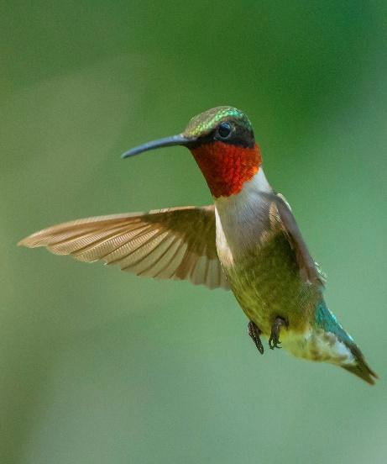 | 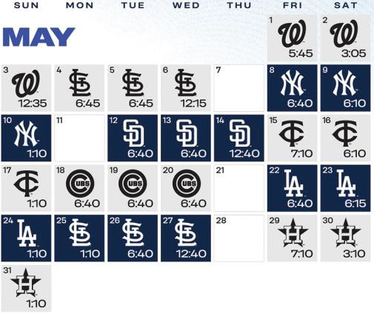
*All activities and locations are subject to change.

